10 SCIENCE BIOLOGY ASSIGNMENT: GENETICALLY MODIFIED CROPS 2016

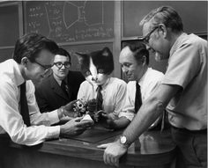

Name:__________________________ Teacher: Miss Cerny

Form:__________________________ Due date: ____________________

Aim: This assignment will allow you to research information about genetically modified food.

Hint: chapter 1.4 of your e-book has information you can use and then reference. I have also attached two pages of information you can read.

Plagiarism:
You must write in your own words not copy sentences word for word from another student or another source.
Plagiarising = instant zero on assignment and you will have to re-do it.

Assessment policy:
Give me a sick note/legitimate reason from parent BEFORE due date = new negotiated due date.
One day late = -20% taken off mark
Two days late = -40% taken off mark
Three days late = mark of zero given, students are required to attend a detention and are still required to submit the assignment.

If you are not at school the day this assignment is due, please email it
to me by 4pm.

s.cerny@aranmore.wa.edu.au

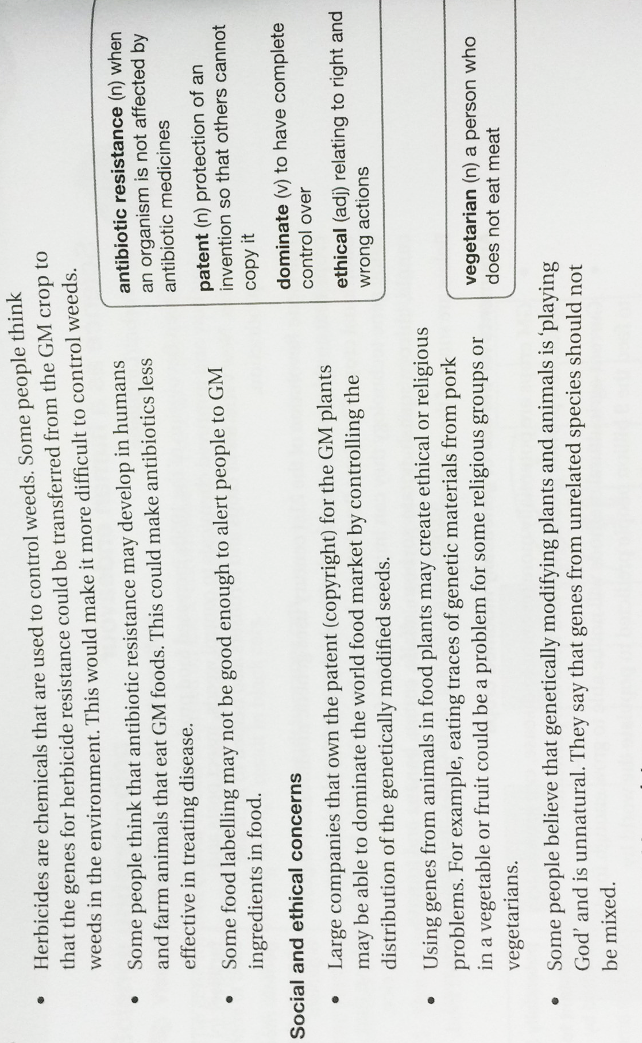
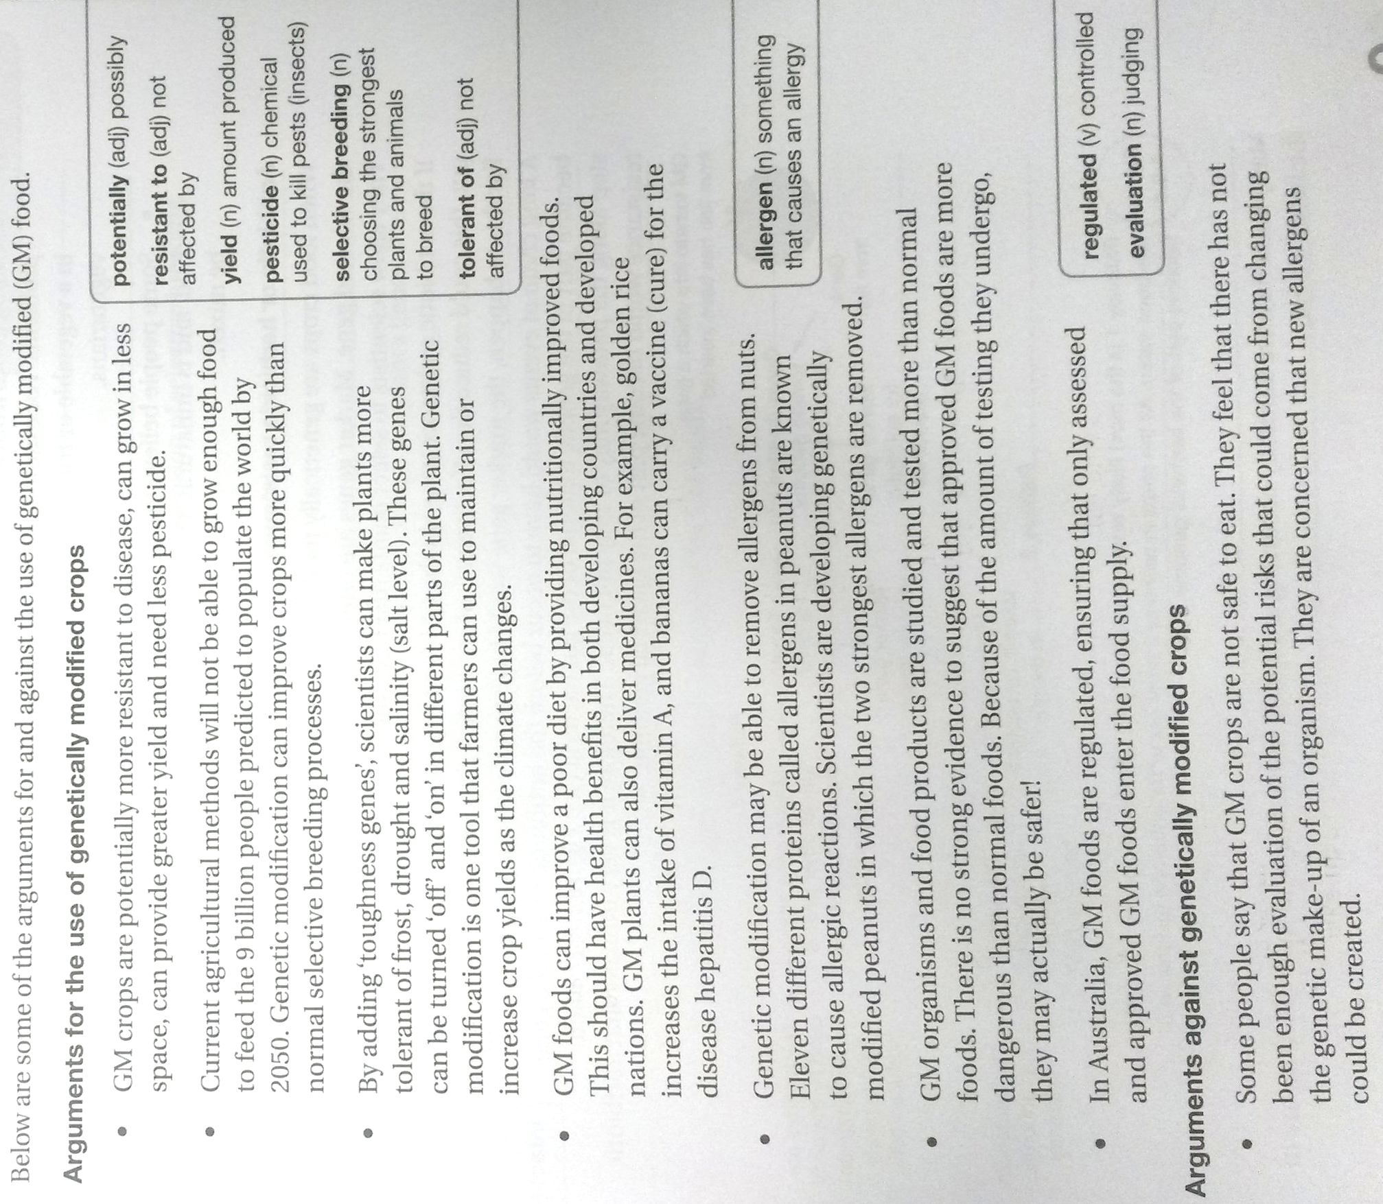

1. In your own words, and in language you understand, write a paragraph (minimum 3 sentences) that explains what genetic modification is. (3 marks)

_________________________________________________________________________________________________

_________________________________________________________________________________________________

_________________________________________________________________________________________________

_________________________________________________________________________________________________

_________________________________________________________________________________________________

_________________________________________________________________________________________________

_________________________________________________________________________________________________

_________________________________________________________________________________________________

_________________________________________________________________________________________________

Choose either GM canola OR Golden rice

Name of your GM crop: _______________________________________________

2. Explain how your chosen crop has been modified (changed).
What is a characteristic that is has now that it didn’t have before it was modified? (2 marks)
_________________________________________________________________________________________________

_________________________________________________________________________________________________

_________________________________________________________________________________________________

_________________________________________________________________________________________________

_________________________________________________________________________________________________

_________________________________________________________________________________________________

_________________________________________________________________________________________________

_________________________________________________________________________________________________

_________________________________________________________________________________________________

_________________________________________________________________________________________________

_________________________________________________________________________________________________

_________________________________________________________________________________________________

4. Describe two advantages of genetically modifying your chosen crop (in full sentences). (2 marks)

_________________________________________________________________________________________________

_________________________________________________________________________________________________

_________________________________________________________________________________________________

_________________________________________________________________________________________________

_________________________________________________________________________________________________

_________________________________________________________________________________________________

_________________________________________________________________________________________________

_________________________________________________________________________________________________

5. Describe three benefits of GM crops in general (not including the benefits you described in question 4). (3 marks)
_________________________________________________________________________________________________

_________________________________________________________________________________________________

_________________________________________________________________________________________________

_________________________________________________________________________________________________

_________________________________________________________________________________________________

_________________________________________________________________________________________________

_________________________________________________________________________________________________

_________________________________________________________________________________________________

_________________________________________________________________________________________________

_________________________________________________________________________________________________

_________________________________________________________________________________________________

_________________________________________________________________________________________________

_________________________________________________________________________________________________

6. Some groups of people are against genetically modified crops (anti-GM). Describe three claims these groups of people make against GM crops and for each one explain whether or not you think it is valid (rational, justifiable) and explain why/why not. (6 marks)

Claim 1: _________________________________________________________________________________________

_________________________________________________________________________________________________

_________________________________________________________________________________________________

_________________________________________________________________________________________________

_________________________________________________________________________________________________

_________________________________________________________________________________________________

_________________________________________________________________________________________________

_________________________________________________________________________________________________

_________________________________________________________________________________________________

Claim 2: _________________________________________________________________________________________

_________________________________________________________________________________________________

_________________________________________________________________________________________________

_________________________________________________________________________________________________

_________________________________________________________________________________________________

_________________________________________________________________________________________________

_________________________________________________________________________________________________

_________________________________________________________________________________________________

_________________________________________________________________________________________________

Claim 3: _________________________________________________________________________________________

_________________________________________________________________________________________________

_________________________________________________________________________________________________

_________________________________________________________________________________________________

_________________________________________________________________________________________________

_________________________________________________________________________________________________

_________________________________________________________________________________________________

_________________________________________________________________________________________________

_________________________________________________________________________________________________
7. Decide whether you support the continued use of GM foods in Australia and justify your decision (explain why). (2 marks)

_________________________________________________________________________________________________

_________________________________________________________________________________________________

_________________________________________________________________________________________________

_________________________________________________________________________________________________

_________________________________________________________________________________________________

_________________________________________________________________________________________________

_________________________________________________________________________________________________

_________________________________________________________________________________________________

8. Look at the following groups in Australia and state whether they are for growing GM crops in Australia or against growing GM crops in Australia. For each group, write a quote you found on the website that supports your answer. (8 marks)

Group | Pro-GM or anti-GM | Evidence to support your answer
Crop Life Australia
www.croplifeaustralia.org.au
Biotechnology Industry
Organization
http://www.bio.org/
Producers Forum
www.producersforum.net.au
True Food Network
www.truefood.org.au

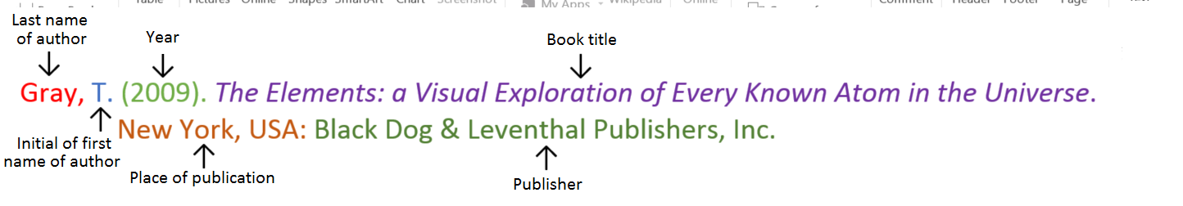
Book
Book with two authors

Shermer, M., & Benjamin, A. (2006). Secrets of Mental Math: The Mathemagician’s Guide to Lightning Calculation and Amazing Mental Math Tricks. New York, USA: Three Rivers Press.

Book with three or more authors

Bulliet, R. W., Alley, R. B., Broecker, W. S., & Denton, G. H. (2011). The fate of Greenland: Lessons from abrupt climate change. Cambridge, MA: MIT Press.

Book with editor

Kasdorf, W. E. (Ed). (2003). The Columbia guide to digital publishing. New York, USA: Columbia University Press.

Book with different editions

Nagle, G., & Cooke, B. (2012). Geography Study Guide: Oxford Ib Diploma Programme (2nd ed.). Oxford, UK: Oxford University Press.

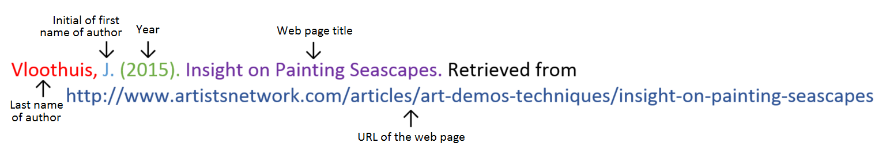
Website

Website with no author (put title of page at the front)

Aranmore Catholic College. (2014). Retrieved from
http://www.aranmore.wa.edu.au/

Website with no date

The Zadkine Museum. (n.d). Retrieved from http://www.france.fr/en/museums/zadkine-museum.html

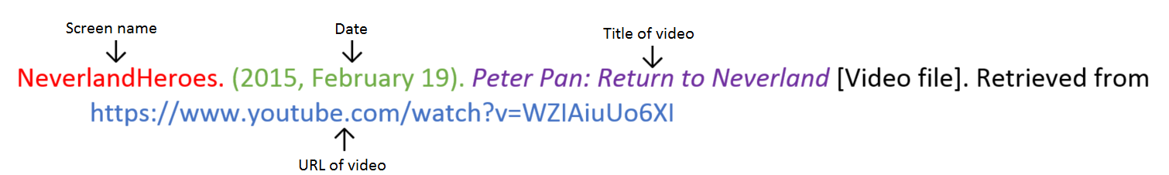
Video file

Reference list

Minimum of two references. (1 mark)
Minimum of two different sources (1 mark)
(Book, encyclopedia, video, website, journal, magazine, newspaper).
Referenced using the APA style on the previous page. (1 mark)

_________________________________________________________________________________________________

_________________________________________________________________________________________________

_________________________________________________________________________________________________

_________________________________________________________________________________________________

_________________________________________________________________________________________________

_________________________________________________________________________________________________

_________________________________________________________________________________________________

_________________________________________________________________________________________________

_________________________________________________________________________________________________

_________________________________________________________________________________________________

_________________________________________________________________________________________________

_________________________________________________________________________________________________

_________________________________________________________________________________________________

Assignment is neatly written or typed. (1 mark)
Correct grammar and spelling. (1 mark)

Total mark: /31 %

Teacher comments: on Seqta

